**Excel Bot Design Document**

**Bot Description:**

This bot will compare two excel files based on functions that are selected by users**.**

**Design**

* There are two excel Files,one file is considered as input file and other is considered as reference file.

**Stage1:**

**A.Transpose data**

* Excel will contain table starting from X Column and Y Row.
* The bot should identify the starting and ending points of the table.
* The bot should remove all the empty rows and columns from left and top portion of the excel.
* The bot will create a new excel with data copied to start from the first column and first row.
* The new excel is considered as input file.

**B.Validations**

* The Bot will identify unique column in the input file.
* Later verifies the column is not null and has unique data.
* If the column has null values,the bot should throw warning to the user.
* Then the bot verifies whether the unique column is present in the reference file.
* If the unique column is not present in the reference file,the bot should throw warning to the user.
* Input file should contain all the data that is present in the reference file.
* List input and reference column names and use them in stage 2.

This is the sample input file(table format)

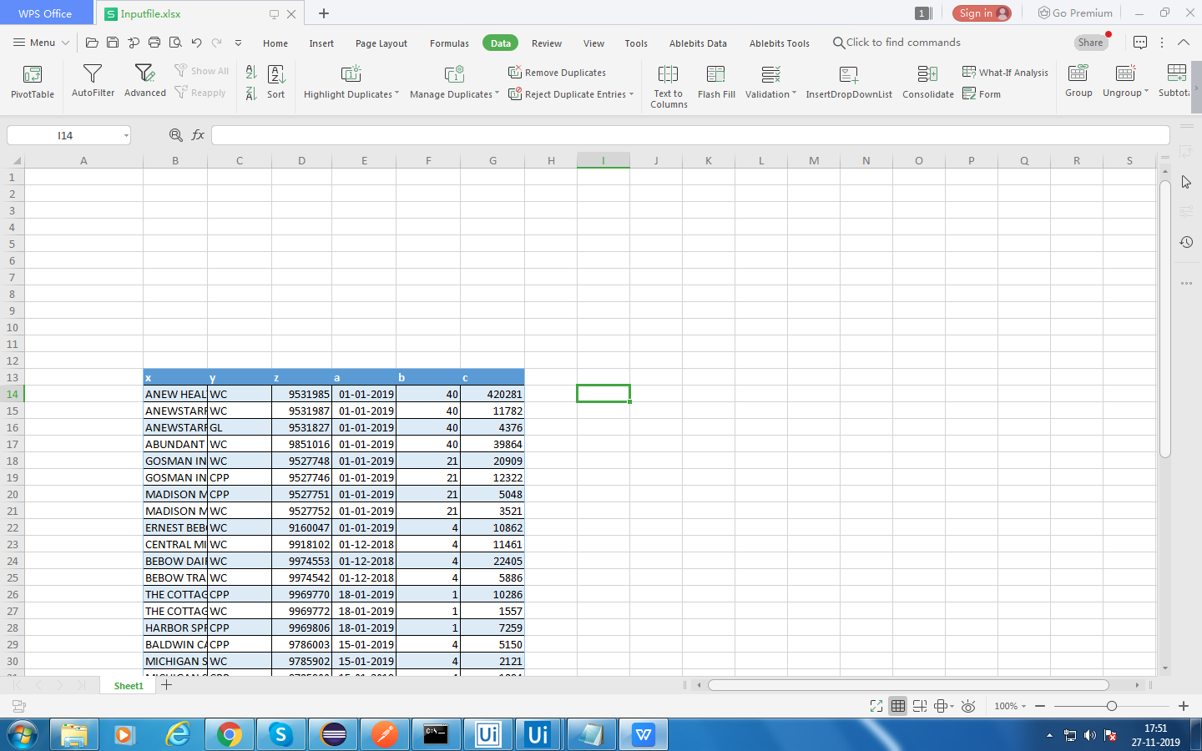

This is the new excel sheet where the table is moved to the beginning of the sheet

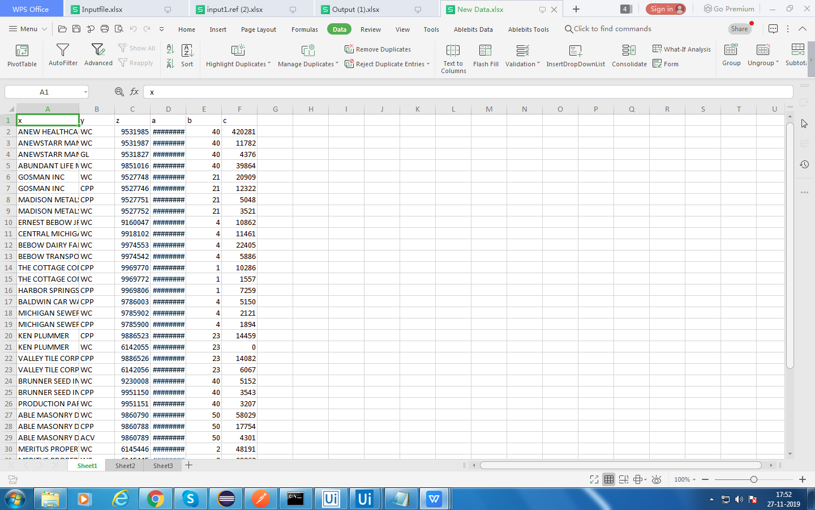

This is the sample reference file

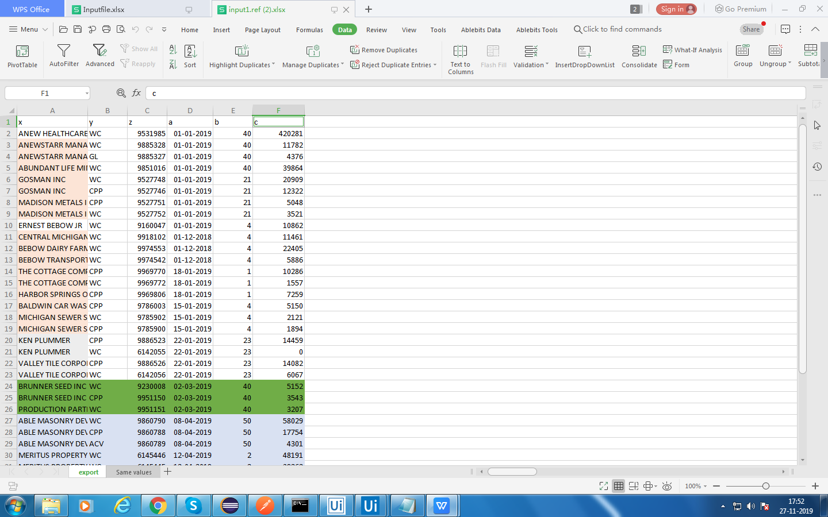

**Stage2:**

A.Selecting templates:

* Form will be created in this stage.
* By default one template will be provided to the user.
* The user will make some changes and submit the form.
* If there are no validations errors,a dialog box appears for user conformation to save the form.
* If there are any validations error the form will be opened again and user make the changes regarding those errors.
* And then the form will be submitted.

B.Uiform:

* The form contains 5 input rows and 5 reference rows.

.

* For each row there will be a dropdown and the dropdown contains all the functions.
* The user can select one function from the dropdown.
* In this form the user will be able to select 5 functions for the input file and 5 functions for the reference file.
* If user selects one function,the bot should verify whether that function related fields are displayed and other functions fields are hidden.

C.Default Values:

* If user selects one function,the function related fields will be displayed and all the fields should contain a default value.

D.Functions:

* Based on selection of the function by the user ,Number of columns will be displayed.

|  |  |
| --- | --- |
| Functions | Number of columns |
| Concatenation | 3 |
| Split | 2 |
| Trim | 2 |
| Asis | 1 , 1 Textfield |

E.Validations:

* The bot will verify whether all the functions have mandatory fields.
* The bot will verify whether all the functions have input/reference fields.
* The bot will verify whether all the fields have values.

This is the form where the user will be able to select the functions.

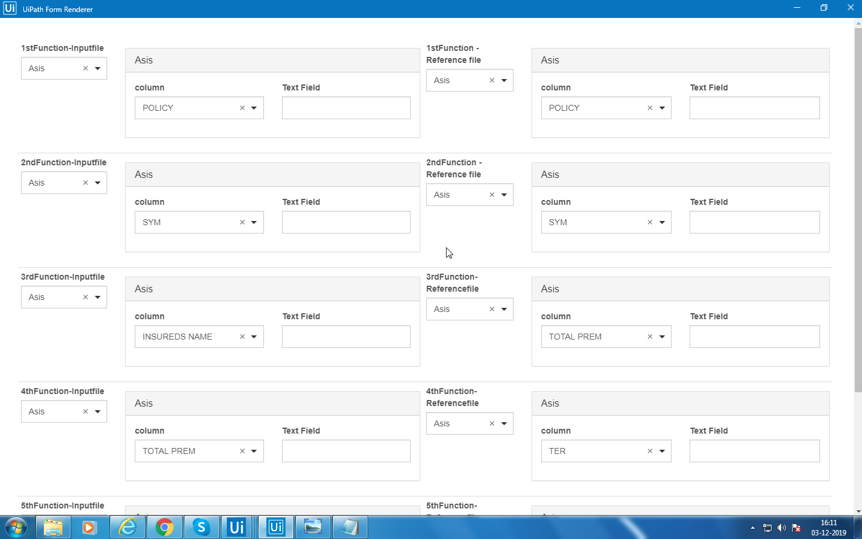

The dropdown contains all the functions

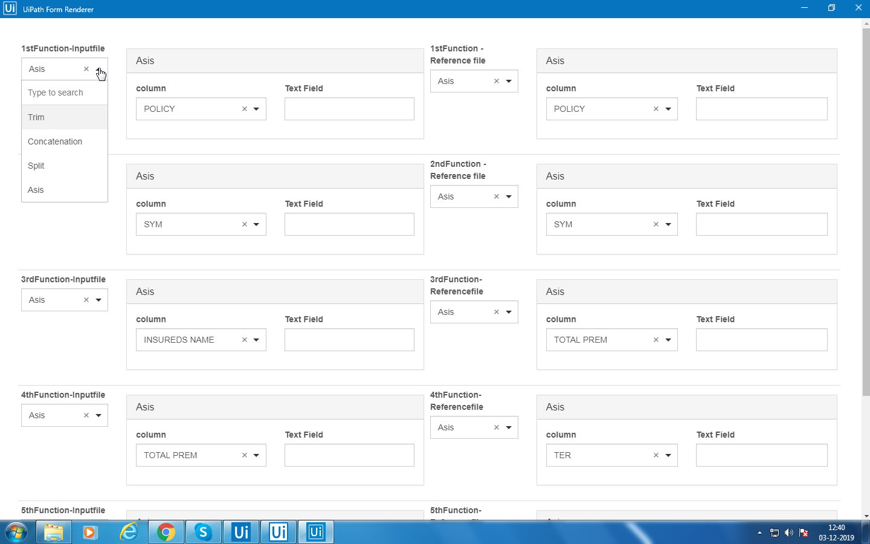

If user selects one function,the function related fields will be displayed.

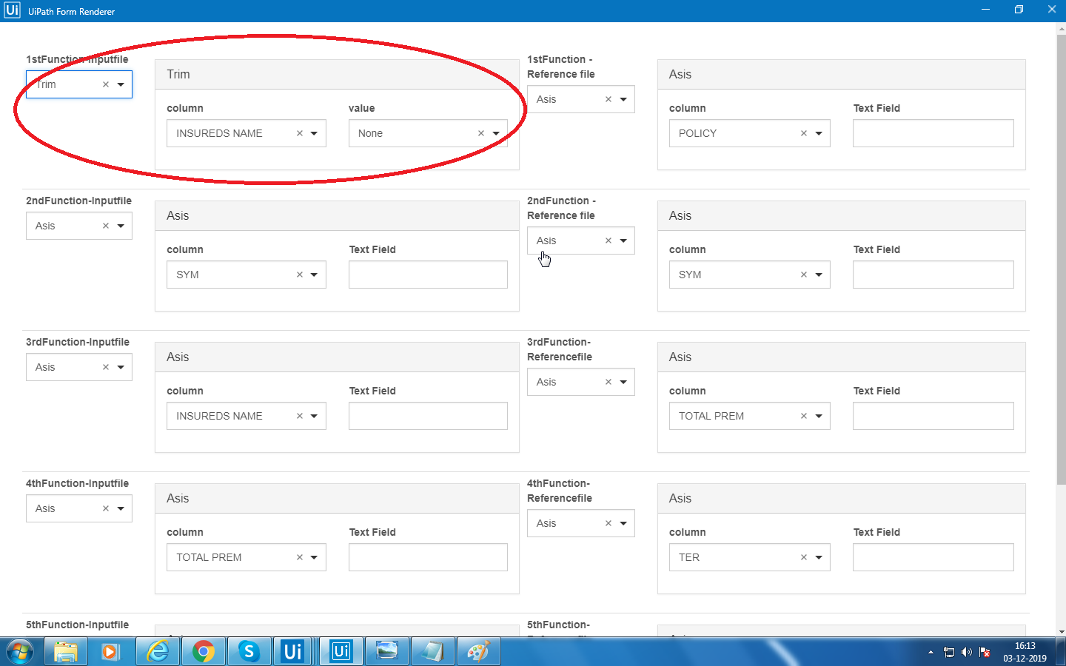

**User Manual:**

Step1:

The input sheet and reference sheet is kept in this folder.

“ C:\Users\SmartBots\Desktop\Excel Bot Design ”

Ensure only input sheet and reference sheet is found in the above folder.

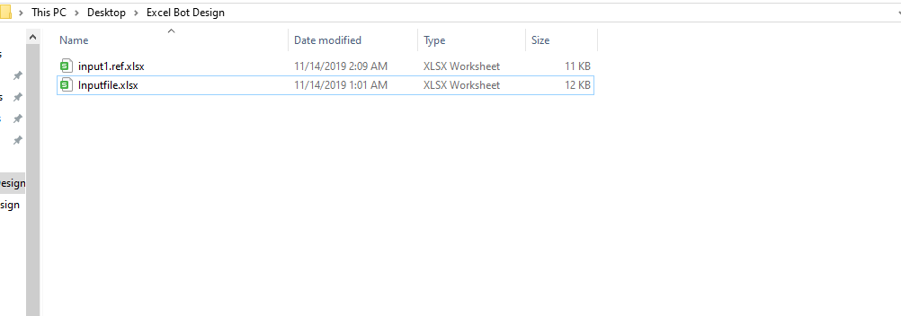

Step2:Excel Bot Process

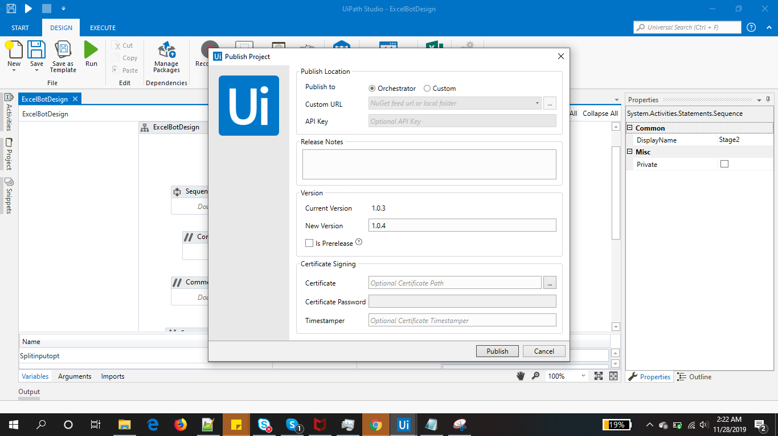

First create the process called ExcelBotDesign.And the ExcelBotDesign process is created.

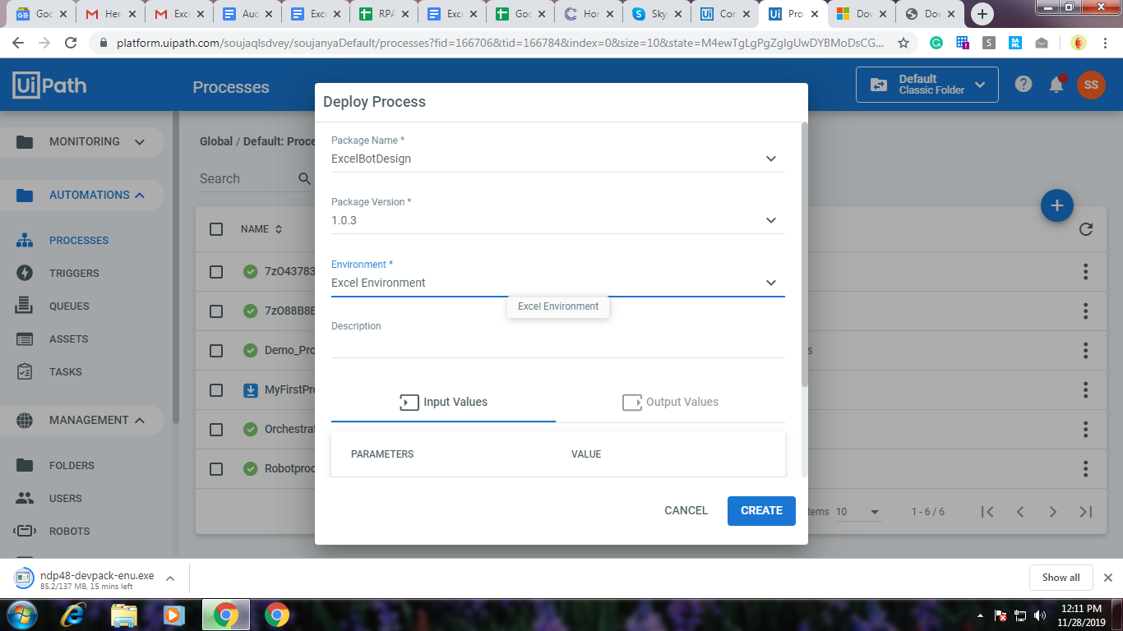

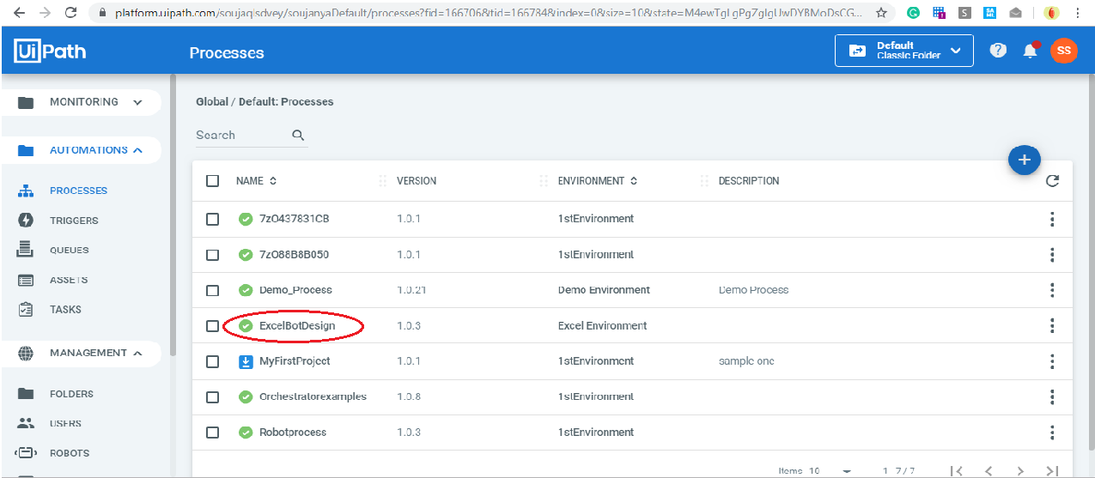

Step3:

Run the bot

To run the ExcelBotDesign process,in jobs click on the start button to run the job then select the ExcelBotDesign process and choose the “1stRobot” Bot to run.Now the process is started

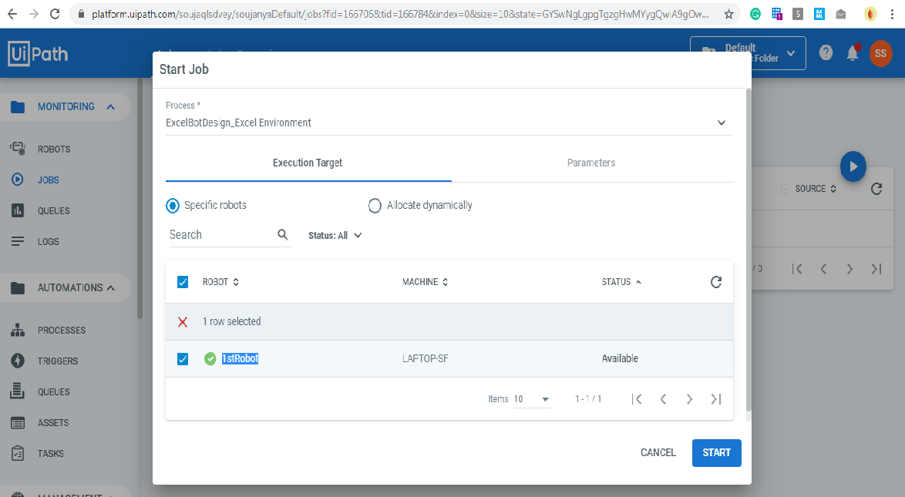

Step4. Check status

Status of the Process can be checked under the State Column.If the Status is Successful then the process is completed.

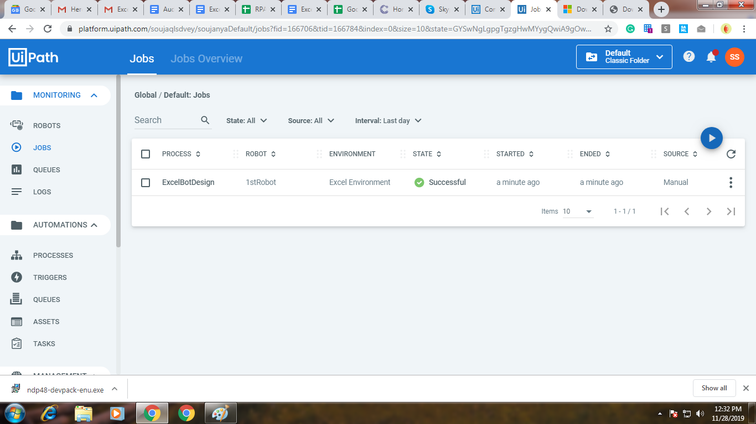

To check the Job details ,click on this details button.

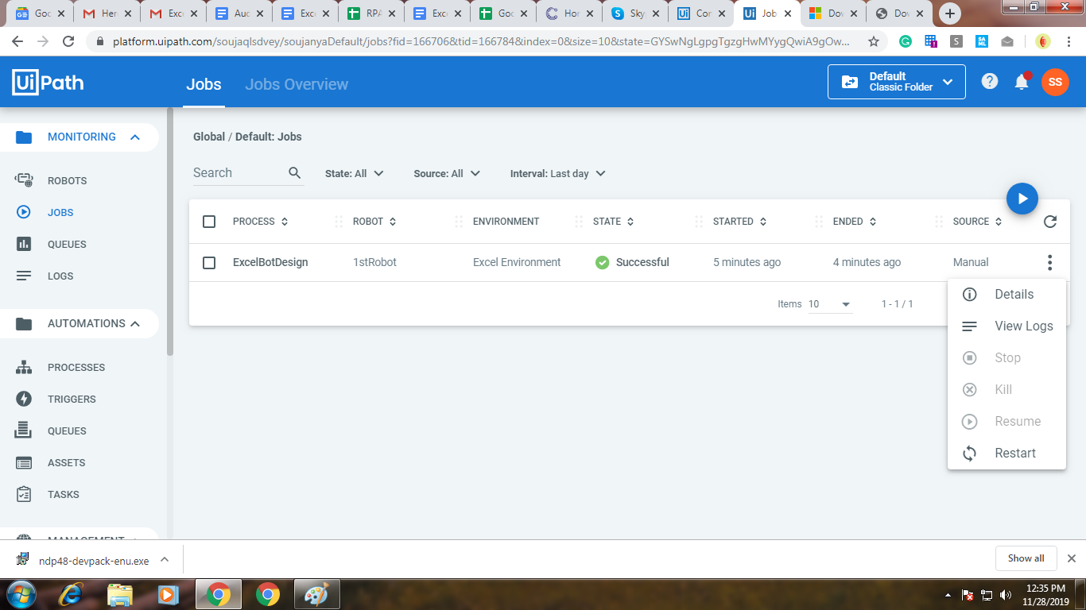

Now to check the logs for that process click on the view logs button.

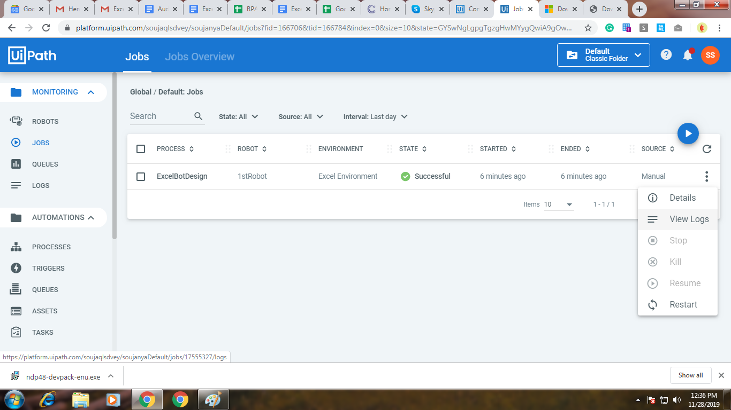

Step5:

The output file is stored in this folder

“C:\Users\SmartBots\Desktop\Excel Bot Design”

